**ASSIGNMENT 2**

# Question:

1. Create a Flask App
2. Add the Home page, About Page
3. Add the bootstrap
4. Add the Signin page and App the Signup Page

# Base.html

<html lang=”en”>

<head>

<!—Required meta tags

<meta charset=”utf-8”>

<meta name=”viewport” content=”width=device-width,initial-scale=1”>

<!—Bootstrap CSS

<link href=[https://cdn.jsdelivr.net/npm/bootstrap@5.2.1/dist/css/bootstrap.min.css](https://cdn.jsdelivr.net/npm/bootstrap%405.2.1/dist/css/bootstrap.min.css)

Rel=”stylesheet” integrity=”sha384-

iYQeCzEYFbKjA/T2uDLTpkwGzCiq6soy8tYaI1GyVh/UjpbCx/TYkiZhlZB6+fzT” crossorigin=”anonymous”>

<script src=[https://cdn.jsdelivr.net/npm/bootstrap@5.2.1/dist/js/bootstrap.bundle.min.js](https://cdn.jsdelivr.net/npm/bootstrap%405.2.1/dist/js/bootstrap.bundle.min.js)

Integrity=”sha384-

u1OknCvxWvY5kfmNBILK2hRnQC3Pr17a+RTT6rIHI7NnikvbZlHgTPOOmMi466C8” Crossorigin=”anonymous”></script>

<!--<link rel=”stylesheet” href=”static/css/style.css”

{% block head %} {% endblock %}

</head>

<body><nav class="navbar navbar-expand-lg bg-light">

<div class="container-fluid">

<a class="navbar-brand" href="chat">chat</a>

<button class="navbar-toggler" type="button" data-bs-toggle="collapse" data- bstarget="#navbarSupportedContent" aria-controls="navbarSupportedContent" aria- expanded="false" aria-label="Toggle navigation">

<span class="navbar-toggler-icon"></span>

</button>

<div class="collapse navbar-collapse" id="navbarSupportedContent">

<ul class="navbar-nav me-auto mb-2 mb-lg-0">

<li class="nav-item">

<a class="nav-link active" aria-current="page" href="home">Home</a>

</li>

<li class="nav-item">

<a class="nav-link" href="signup">signup</a>

</li>

<li class="nav-item dropdown">

<a class="nav-link dropdown-toggle" href="#" role="button" data-bs-toggle="dropdown" aria- expanded="false">

Dropdown

</a>

<ul class="dropdown-menu">

<li><a class="dropdown-item" href="about">About</a></li>

<li><a class="dropdown-item" href="blog">blog</a></li>

<li><hr class="dropdown-divider"></li>

<li><a class="dropdown-item" href="signin">Signin</a></li>

</ul>

</li>

<li class="nav-item">

<a class="nav-link disabled">disabled</a>

</li>

</ul>

<form class=”d-flex” role=”search”>

<input class=”form-control me-2” type=”search” placeholder=”Search” aria-label=”Search”>

<button class=”btn btn-outline-success” type=”submit”>Search</button>

</form>

</div>

</div>

</nav>

<div class=”container mt-5”>

{% block body %} {% endblock %}

</div>

</body>

</html>

## Signin.html

{% extends ‘base.html’ %}

{% block head %}

<title>Signin page</title>

{% endblock %}

{% block body %}

<h2>Signup Forms</h2>

<form action=”/signin”>

<label for=”fname”>First name:</label><br>

<input type=”text” id=”fname” name=”fname” class=”form-control” ><br>

<label for=”lname”>Last name:</label><br>

<input type=”text” id=”lname” name=”lname” class=”form-control”><br><br>

<input type=”submit” value=”Submit”>

</form>

<p>If you click the “Submit” button, the form-data will be sent to a page called

“/action_page.php”.</p>

{% endblock %}

# App.py

from flask import Flask, url_for, render_template, request, redirect from markupsafe import escape

app = Flask( name ) app.config['SECRET_KEY']="KIIU54RYBMKLO8321S"

all_posts= [

{

'title':"Blog post 1", 'content': "This is first Post", 'author':'DEV'

},

{

'title':"Blog post 2", 'content':"This is second Post"

}

]

@app.route("/") def index():

return '<h1>Welcome to home Page</h1>'

@app.route("/login") def login():

return 'login'

@app.route('/blog') def blog():

return render_template('blog.html', posts=all_posts)

#dynamic routing

@app.route("/users/<username>") def profile(username):

return render_template('profile.html', username=username)

@app.route("/signin") def signin():

return render_template('signin.html')

@app.route("/signup") def signup():

return render_template('signup.html') @app.route("/home") def

homepage():

return render_template('home.html')

@app.route("/about") def about():

return render_template('about.html')

messages = [{'title': 'Message One', 'content': 'UNDERGRADUATE STUDENTS'},

{'title': 'Message Two', 'content': 'FLASK APP DEMO'}

]

@app.route("/chat") def chat():

return render_template("chat.html", messages=messages) **SIGNUP.HTML**

{% extends “base.html” %}

{% block title %}Signuppage{% endblock %}

{% block body %}

<body>

<!—Main div code 

<div id=”main”>

<div class=”h-tag”>

<h2>Create Your Account</h2>

</div>

<!—create account div 

<div class=”login”>

<table cellspacing=”2” align=”center” cellpadding=”8” border=”0”>

<tr>

<td align=”right”>Enter Name :</td>

<td><input type=”text” placeholder=”Enter user here” class=”tb” /></td>

</tr>

<tr>

<td align=”right”>Enter Email ID :</td>

<td><input type=”text” placeholder=”Enter Email ID here” class=”tb” /></td>

</tr>

<tr>

<td align=”right”>Enter Username :</td>

<td><input type=”text” placeholder=”Enter Username here” class=”tb” /></td>

</tr>

<tr>

<td align=”right”>Enter Password :</td>

<td><input type=”password” placeholder=”Enter Password here” class=”tb” /></td>

</tr>

<tr>

<td align=”right”>Enter Confirm Password :</td>

<td><input type=”password” placeholder=”Enter Password here” class=”tb” /></td>

</tr>

<tr>

<td></td>

<td>

<input type=”reset” value=”Clear Form” id=”res” class=”btn” />

<input type=”submit” value=”Create Account” class=”btn” /></td>

</tr>

</table>

</div>

<!—create account box ending here.. 

</div>

<!—Main div ending here… 

</body>

{% endblock %}

## ABOUT.HTML

{% extends "base.html" %}

{% block title %}Aboutpage{% endblock %}

{% block body %}

<div class="about-section"> <h1>About Us Page</h1>

<p>personal expense tracker application</p>

<p>JAIKEERTHI(teamlead)</p>

</div>

<h2 style="text-align:center">Our Team</h2>

<div class="row">

<div class="column">

<div class="card">

<img src="/w3images/team1.jpg" alt="RITHANI " style="width:100%">

<div class="container">

<h2>RITHANI</h2>

<p class="title">tester</p>

<p>teammember1.</p>

<p[>rithu27@gmail.com](mailto:%3erithu27@gmail.com)</p>

<p><button class="button">Contact</button></p>

</div>

</div>

</div>

<div class="column">

<div class="card">

<img src="/w3images/team2.jpg" alt="SATHURAKKSHAYA" style="width:100%">

<div class="container">

<h2>SATHURAKKSHAYA </h2>

<p class="title">software developer</p>

<p>team member2</p>

<p[>sathu2905@gmail.com.com](mailto:%3esathu2905@gmail.com.com)</p>

<p><button class="button">Contact</button></p>

</div>

</div>

</div>

<div class="column">

<div class="card">

<img src="/w3images/team3.jpg" alt="NAVAL KUMARAN" style="width:100%">

<div class="container">

<h2>NAVAL KUMARAN </h2>

<p class="title">frontend developer</p>

<p>team member3</p>

<p[>naval30062002@gmail.com](mailto:%3enaval30062002@gmail.com)</p>

<p><button class="button">Contact</button></p>

</div>

</div>

</div>

</div>

{% endblock %}

## HOMEPAGE.HTML

{% extends “base.html” %}

{% block title %}Homepage{% endblock %}

{% block body %}

<h1 class=”text-center”>Simple Flask App</h1>

<div class=”row”>

<div class=”col-sm-6 offset-sm-3”>

<div class=”jumbotron”>

Welcome to this simple Flask example app.<br>HOMEPAGE<br>

</div>

</div>

</div>

{% endblock %}

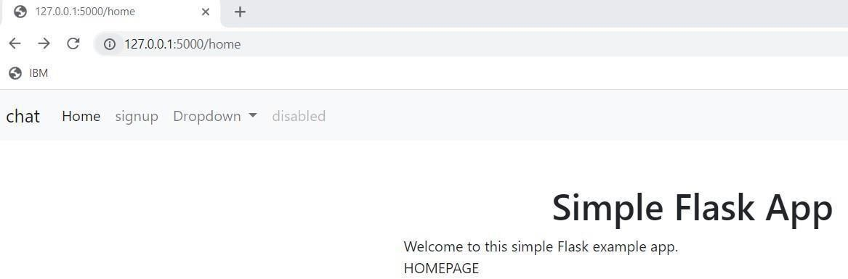

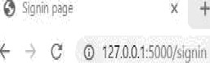 



Signin Forms

fiist name:

Last name-

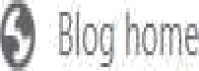 x *)*

t C é 117001l0B/bl0j





‹ii/«s



âl0§ §0St /

6tt0f.Df¥



+ 0 0 1z7.0.0 1:5000/about 



Our Team

SWETHA

JEYADHARSHINI



KAVIBHARATHI

@ 127.0.0.1:5000/* ›9nup 

E W @ 127.0.0.1:5000/signup @ IBM

chat Home signup Drop do\<'n • wi-. : :e‹

Create Your Account

Enter Name :





EnterConfrm Password :

